10
10. thumb
11
12
12. ears
11. check
14
4
4. eye, pupil
3
3.eyelash(es)
2
2.eyebrow(s)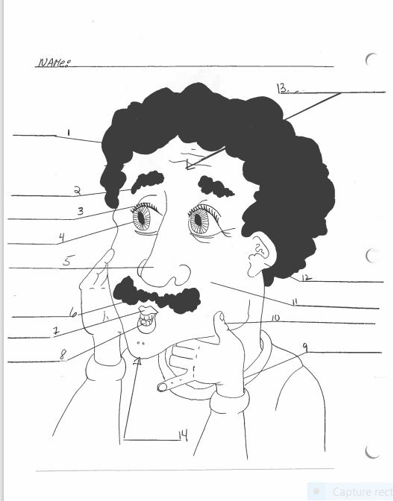brow(s)
12
13
9
9. wrist
8. one tooth
many teeth
h
8
14. chin
7
7. lip(s)
6
6.mustache
5. nose
1
13. forehead
1.hair

